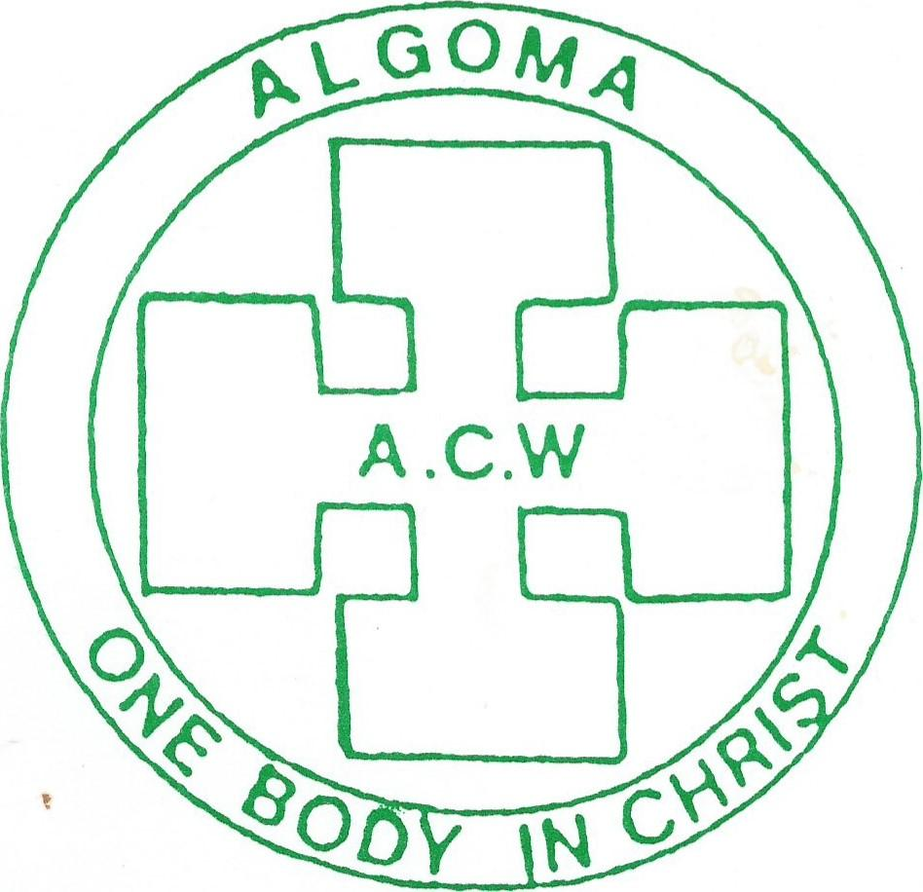
Algoma Anglican Church Women
53rd Annual Conference Via Zoom
Wednesday, May 26, 2021
We, the many, are “One Body in Christ, and every one,
members one of another. ... Romans 12:4

REGISTRATION FORM TO BE RETURNED
First & Last Name_________________________________________

Email __________________________________________________
Deanery ________________________________________________
Registration Fee $15.00 Thank Offering $10.00____$20.00 Other_______
If you would like to contribute to the Thank Offering, please write Registration fee and Thank offering on the memo line of your cheque or in the memo line of e transfers.

Please return this form and payment NO LATER THAN MAY 6TH
Cheque payable to: ACW Diocese of Algoma
Mail to: Jacquie Howell 401 – 35 Dairy Lane Huntsville P1H 2L8

e transfers payable at acwjacquie@gmail.com (please, email registration form)
Your Invitation and Annual booklet will be emailed to you prior to the Annual.

